Getting Started
ERD, System Specification, SWOT Analysis

Getting Started 1
Creating the System Specification 1
Creating the Individual Specifications 3
Team Work v Group Work 4
Some Tips for Creating the Specification Document 4
When do we Delete Data? 8
What are Your Business Rules? 9
Creating the SWOT Analysis 10

Getting Started
To get started on the system we are going to put together two important documents.
- The System Specification
- The Entity Relationship Diagram
The System Specification will consist of a written statement stating what the system as a whole will do.
There will be four parts to the document...
- The Core Functionality
- The System Overview
- Individual Specifications
- The SWOT Analysis
The Entity Relationship Diagram will show in graphical form the entities used in the system along with data dictionaries for each table.

Creating the System Specification
You need to start by thinking as, a team, about what your system is going to do, the System Overview and Core Functionality. These may be written as a single word document shared between the team members.
You may want to try OneDrive or Google docs so that you may create shared versions of these documents.
Create a blank word document for the whole team and define what your system will do starting with a single sentence, for example...
“Our system will sell widgets”
This is the Core Functionality Definition. It defines the system in a single sentence and is a good way of really tightening the focus of the system. If you cannot do this then your definition is likely too vague.
Once you have the Core Functionality defined you need to expand the idea into a paragraph or two of descriptive text...
This program will sell widgets to the general public. They will have access to a web based front end allowing them to browse and filter the available stock of widgets. There will be options for the customer to place widgets into a shopping cart and create an order. Upon creation of an order there will be a requirement that they create an account where they specify their personal details along with security and payment data. There will also be facilities for them to review and modify orders.
In addition to a customer facing front end there will also be a staff facing back end. Once an order is created by the customer it will be added to a list of orders for processing at the back end. The back end will allow for a range of admin functions such as managing customer data, staff data, stock and running various reports on data stored in the system e.g. orders placed.
Once you have an idea of what the system will do you need to identify who is taking on what section of the system development.
In this example the development team consists of four people, Rod, Jane, Freddie and Bungle.
For the assessment each team member must complete the full range of documents for their allocated section. Each team member is also responsible for all layers of their component, interface, middle layer classes and database components.
Remember this is team work not group work.
Each member stands or falls on the work that they themselves develop.
In this team we will allocate the following components to each team member...
- Rod Staff management system
Allowing adding, editing, deleting, listing and filtering of staff records
- Jane Customer management system
Allowing adding, editing, deleting, listing and filtering of customer data
- Freddie Stock management system
Allowing for maintenance of stock data, add, edit etc..
- Bungle Order processing
Allowing for customers to input an order and for staff to process that order to dispatch
As a rough guide allocating a single table to each team member results in each member having a similar amount of work to do.
Notice that not all aspects of the system will be completed by the end of the project; this is fine as we lack both time and people to take the system to completion.
This should give you a single document along the following lines (clearly more work is needed here)...

Perfect Widget LTD

Est. 2019
Core Functionality: A System for Selling Widgets
Team Members: Rod
Jane
Freddie
Bungle
System Overview:
This program will sell widgets to the general public. They will have access to a web based front end allowing them to browse and filter the available stock of widgets. There will be options for the customer to place widgets into a shopping cart and create an order. Upon creation of an order there will be a requirement that they create an account where they specify their personal details along with security and payment data. There will also be facilities for them to review and modify orders.
In addition to a customer facing front end there will also be a staff facing back end. Once an order is created by the customer it will be added to a list of orders for processing at the back end. The back end will allow for a range of admin functions such as managing customer data, staff data, stock and running various reports on data stored in the system e.g. orders placed.

Try to think of yourselves no longer as students but as a company producing stuff. Think of a name for your company; why not come up with a logo?

Creating the Individual Specifications
Now that the team has created and agreed upon the System Overview, each team member is responsible for developing the detail related to their specific allocated component.

Team Work v Group Work
You are most welcome to help and support each other in this task but resist the urge to do the work for another person.
You are marked individually remember!
If you complete the work for a team member who does nothing they will be awarded the marks based on your hard work, which isn’t fair.

Some Tips for Creating the Specification Document
One common problem with individual specifications such as this is that they are often too vague to really tell us what is going on.
Although it isn’t necessary to produce a formal role-play it is a good idea to try an imagine oneself in the situation of the potential user.
- Who?
- What?
- When?
- Where?
- Why?

(If you are not clear on any of these points then you must return to the client and find out, or in our case discuss the matter with your tutor.)
Also think about the typical tasks that any system has to cater for...
- Add
- Edit
- Delete
- List
- Filter
- Find
- Validate
Ok – let’s set the scene.
Looking at the team we have the following members allocated with the following tasks...
- Rod Staff management system
Allowing adding, editing, deleting, listing and filtering of staff records
- Jane Customer management system
Allowing adding, editing, deleting, listing and filtering of customer data
- Freddie Stock management system
Allowing for maintenance of stock data, add, edit etc...
- Bungle Order processing
Allowing for customers to input an order and for staff to process that order to dispatch
Jane has taken on the task of developing the customer management system.
It is worth keeping in mind that each part of the system has a customer facing front end and a staff facing back end.
Perhaps when Jane has a first stab at expanding the details they might look like this...
A customer visits the web site to buy some widgets. They go through the main log-in page and then start to browse the list of available widgets. Upon finding out that they are not a customer they follow the sign-up process entering their details and selecting a user name and password. Once they see widgets that they need by browsing the stock list they add them in turn to the shopping cart. Once they have completed this process they proceed to check out and complete the order. Customers have the option to modify their personal data and also close their account.
On the back end of the system staff process the order placed by the customer. They also have the option to manage the data for customers (add, edit delete) and run reports on customers.
As a first stab it isn’t bad. Don’t worry about getting it perfect on the first attempt.
It is a good idea to sit back and think about if this makes sense or not.
First off there seems to be some overlap between Jane’s customer system and Bungle’s order processing.
Who does the shopping cart functionality actually belong to? Is it Jane or Bungle?
As a rule it is not a good policy to start writing system components that somebody else is getting paid for!
There is also another more subtle question to ask here?
Is the customer functionality to treat customers as actors or as entities (units of data)?
What does that mean?
Consider the following use case diagram...
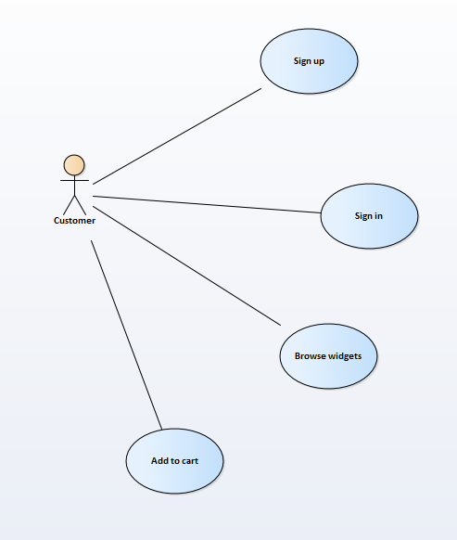
Here we are looking at what the customer does to the system as an actor.
Unfortunately Jane has the wrong idea here.
It isn’t what the customer does to the system as an actor that matters to Jane; it is what actors do to customer data within the system that really matters.
For example...
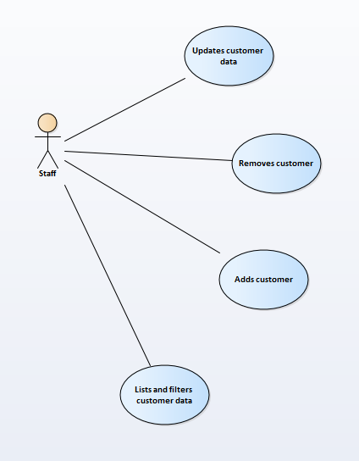
It is the management of customer data that is important.
The confusion comes about because “customer” is both data and actor in that they may manage their own data (but not data belonging to other customers)
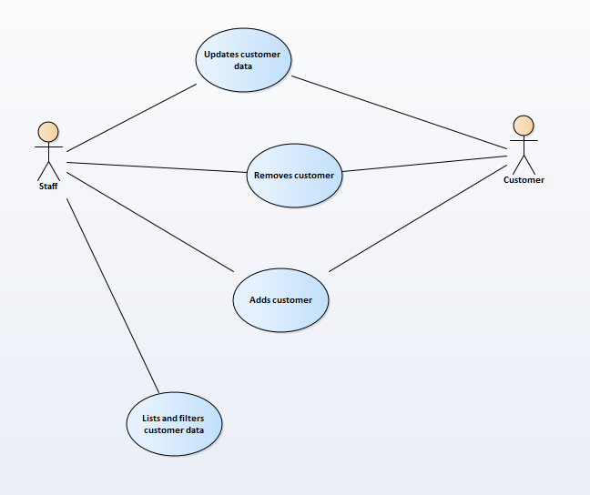
Taking into consideration these issues Jane needs to review her written description which results in shopping cart functionality dropping off her list...
A customer visits the web site to buy some widgets. They have the option to add themselves as a customer to the system and edit their details. Also they are able to cancel their account on-line. Upon finding out that they are not a customer they follow the sign up process entering their details and selecting a user name and password.
On the back end of the system staff have the option to manage the data for all customers (add, edit delete) and run reports on customers.
There are also question here about when do we get to delete customer data?

When do we Delete Data?
Deleting a customer is a potential big deal because as a company we want to hold onto their data as long as possible also deleting customer data has the potential to break our database as we could generate orders with no customer. Under law (GDPR) if a customer requests to be removed from the system we likely will have no choice but to do so.

What are Your Business Rules?
There are also questions here about who gets to add customers to the system. In many web sites customers sign themselves up on-line.
If I want to become an Amazon customer there is no option for me to ring up Amazon HQ and ask one of their members of staff to do it for me.
In other businesses the rules for adding customers are different. In a University system students are added solely at the back end and never sign up on line via the front-end.
These are all questions that you need to think about and address as you start to understand what your allocated section of the system is supposed to do.
Once the Individual Specification is complete you end up with a new document along the following lines...

Perfect Widget LTD
Est. 2019
Allocated Component: Customer Management System
Developer: Jane
Overview:
A customer visits the web site to buy some widgets. They have the option to add themselves as a customer to the system and edit their details. Also they are able to cancel their account on-line. Upon finding out that they are not a customer they follow the sign up process entering their details and selecting a user name and password.
On the back end of the system staff have the option to manage the data for all customers (add, edit delete) and run reports on customers.

As before there is more work to be done with this document and each team member needs to have their own version of this document detailing what their allocated component is going to do.

Creating the SWOT Analysis
SWOT stands for...
- Strengths
- Weaknesses
- Opportunities
- Threats
A SWOT analysis is a really good way of getting to know each other in your team.
To create this document you need to discuss with each other who is good/weak at different skills, what are the opportunities this module may bring and what may be the threats stopping you performing well on the module.
Part of the point of being in a team is to support each other and it really helps to identify the gaps and the strengths in the team at the start.
How you structure this document is up to you and it is very much for your benefit that you complete this.
Here is a partially completed SWOT Analysis to give you an idea of the structure...

Perfect Widget LTD
Est. 2019
SWOT Analysis
Strengths:
Rod Programming, Database Design
Jane Systems Analysis, Interface Design
Freddie Programming, HTML
Bungle Database Design
Weaknesses:
Rod Systems Analysis
Jane Programming
Freddie Database Design
Bungle Programming
Opportunities:
This module offers a chance to learn important skills in team work and be exposed to new software e.g. Enterprise Architect.
Threats:
- Poor communication
- Team members not engaging with the process

Notice above in the strength and weaknesses we have already identified where the skills are in the team.
Look at Rod and Jane...
Strengths:
Rod Programming, Database Design
Jane Systems Analysis, Interface Design
Weaknesses:
Rod Systems Analysis
Jane Programming
Given that their skill sets complement each other they really need to think about support each other.

